Legislative Interviews

January 16, 2021

League of women voters st. louis park

TOpics for discussion
On 1/14, the LWVMN State Board sent a letter to the Minnesota House of Representatives and Senate leadership in both parties. Due to the about the growing evidence of possible violence being directed at elected and government officials prior to inauguration, and about the ongoing use of the baseless claims of voter fraud as a reason for this insurrection behavior. We are specifically calling on our Legislative Leaders to:
- Require that all Minnesota State Representatives and Senators tell the truth about the settled 2020 elections as a duty to fulfill their oath to the United States and Minnesota constitutions;
- Require certain legislators who have incited lies and violence to issue a public message immediately disavowing the falsehoods about a “stolen election,” apologizing for the use of those lies for political purposes, and accepting of the 2020 election validity and integrity, and a clear message that harassment and calls for violence toward our public officials will not be tolerated; and
- Seek consequences and accountability of those legislators who have continued to violate their oath of office by spreading lies about the election through formal censure, the revocation of committee assignments, and even expulsion if needed, should their behavior of spreading lies and misinformation continue.
Can you share your thoughts about what the LWVMN is requesting/proposing?

- Hot topics (not in order of priority, except for the first one)- these are the themes in the questions received ahead of time- please keep these topics in mind when talking about your work and priorities:
  - Your legislative priorities
  - Redistricting
  - Restoring voting rights
  - Homelessness (not just affordable housing)
  - Public health
  - Clean energy
  - Economically disadvantaged people most affected by COVID/COVID response
  - Budget
  - State University and College system funding
  - Education/schools
  - Police reform and oversight
  - Omnibus bills vs single subject bills
  - Health care access and reform
  - Gun control
  - Publicly funded elections

ADDITONAL QUESTIONS AT THE END OF THE DOCUMENT
QUESTIONS SUBMITTED BY PARTICIPANTS DURING THE EVENT

Responses and discussion
LWV Letter
Ryan: Not sure what we can enforce without violating the first amendment. We need to be careful about how to apply ethics. Need to identify the distinction between speeches and enforce truth telling formally. Formal response is dangerous from a policy standpoint.

Ron: The LWV is right to demand that kind of accountability. There is no organization better suited to make that kind of call. Community speech is important.

Cheryl: This is tough, there is free speech and there is incendiary speech. Can a body have decorum without free speech. We’ve never seen words causing actions playing out on our TVs. I think where we go from here is calling it out when it happens. Figuring out consequences is what we need to figure out right now.

Ron: I agree with Cheryl’s distinction between lies and calls to action.

Priorities
Cheryl: We had a security briefing yesterday. We have to be good consumers. There is a difference between social chatter and operational chatter. Home Town Heroes act is one of my bigger bills. It is a fund to help police and firefights with cardiac, cancer and mental health issues. Working on a bill on whether we need a silver alert. And how to treat folks when there is an alert. And working on a mental health bill for 16 year-olds to be able to get mental health help without parental consent. COVID has changed the delivery of our systems. I’m the Property tax chair. We want to make sure everyone can build generational health. Affordable housing: SLP is looking for different ways to get TIP funding. Looking for a way to do an assessment for energy improvements.

Ryan: I carry only a few bills as caucus leader. I’m working on legalizing and expunging cannabis and providing access to driver’s licenses for undocumented residents, and using EMDR for veteran’s therapy. My role is to keep 70 people together. We have a diverse group of legislators and districts have different priorities and needs. We have been reaching out to organized labor to be sure their needs are being addressed – especially those who have been impacted by COVID. Need paid family leave. Safety and security of the house is also a priority. Understanding what federal funds will be available and making sure Minnesota families have access to resources to ensure they feel secure. Instead of using seniority, we have elevated people of color to leadership positions/chairing committees. This is how we can imbed the equity concerns in everything that we do.

Ron: I’m disappointed that we did not take the majority of the senate. It will be difficult to pass priorities in the house. With 2 senators going from DFL to independent we don’t have the votes. I am the ranking minority on the judicial committee and civil law committee. I have been able to get bills passed with bipartisan support: data practice, civil forfeitures, Budget will be a challenge. $643M surplus in the biennium. Some will go to $1.3B shortfall predicted next biennium. I will be adopting what the house pushes forth doing whatever I can to advance those positions – what policies to advance to the governor. Police – will be a challenge to get GOP to agree to make any changes. Consumer protection work, there is concern for how big tech can use our data. Advocate for family leave and prohibiting the practice of suspending driver’s licenses for unpaid fines. Spearheading the effort to make practices easier due to COVID – we will need to ensure they don’t expire. Some of these changes will be permanent.

Is the current legislature makeup going to impact some of the LWV priorities?
Ron: Felon voting – very little support. Gun violence, background checks, we have fewer votes now than we did in the past. I would not expect to see any progress. The ability to carry firearms in the capitol (people can carry firearms at the Capitol and don’t even need to notify Capitol Security). The statue allows this today – it’s possible this may change.

Ryan: GOP are status quo oriented. We’ve had success preserve the provider tax. Last year after 7 special sessions we passed the largest public works bill in history. Police reform bill passed because of overwhelming pressure from the business community. 13 week unemployment extension passed due to public pressure. We need to make it easier for workers to get help with COVID.

Cheryl: We are the only divided legislature. We have an opportunity to show folks can come together. Not all folks in the party have the same priorities. We have to pass a budget. We need to be sure to help the folks harmed by COVID and make sure we can rebuild Minneapolis. Encourages everyone to get engaged with their elected official.

Redistricting:

Ryan: Not a lot be done until we get the data. Mary Murphy will be leading the effort. Each will publish a set of maps and a civil lawsuit will be filed. Hennepin County is the biggest growing county which may result in more DFL representative.

Voter suppression:
Ron: A couple of bills have been introduced in the senate. Require photo ID, voter ID card and provisional ballot establishment. Election day provisional ballot requirement. They think it is an important party priority and supports the claim that there is voter fraud. SF 5.

Cheryl: Provisional balloting is very concerning to me. In my viewpoint this is unacceptable. I worry they will attach some of these strings to a budget conversation.

Ryan: We will be introducing a democracy bill next week. We want to show this is what Minnesota actually needs and show that stolen election rhetoric is dangerous. Last summer we did pass a bill to enable local governments more election flexibility. The success was because we didn’t push the governor to require a mail in ballot.

Ranked Choice Voting (RCV)
Cheryl: Supports using it locally.

Ron: Supports using RCV locally but is withholding judgement for statewide use. Wants to see more local experience.

Ryan: Supports RCV for local elections. I’m still a sceptic. My concern a simple system to explain how people win is better. Wants to ensure it provides the benefits people claim. Simpler is better in my opinion.

Lynne: I was On the Charter Commission and studied RCV 10 years ago. RCV started in San Francisco. We waiting for when we had new voting machines installed. When Minneapolis had 35 people enter the race it was because they were allowed to enter the race at a very low level. Benefits: we eliminate the primary election. Also candidates had the cost of running 2 elections. Plus there was the cost of primary election. I think we will see a good election next year for mayor and city council.

NRA
Ron: Stand your Ground bill extends the range when you don’t need to shoot first ask questions later in any setting (not just your home), including cars, parks, etc. Today you are required to try to get yourself to a safe place. NRA has been quieter. Gun owner’s caucus has been the most effective voice in Minnesota.

Budget
Margaret asked about funding for the education gap– how to advocate for separate funding so it is not included in community education funding. Cheryl has not heard that the funding will change. Staffers are suggesting CARES funding will be available too.

Ryan: Budget forecast is looking better. It was based on no federal funding. Expect more federal assistance, and funding for local government aid. I would be surprised if we have a deficit next year.

Ron: Expect 3 billion dollars for COVID. That will be a great boost. The pandemic is unpredictable. He is concerned about the variant of the COVID that might require additional shut downs.

All were optimistic that although there is a short-fall currently modeled for the next biennium, that it is manageable and will be resolved.

Environment
Ron: Climate change is only down 8%, mainly achieved by the decrease in coal burning plants (not due to less driving during the pandemic). Transportation and agriculture need to adjust. Minnesota is falling short on reaching energy goals. We may see more action in congress now. Bill introduced: prove mining is safe first.

Ryan: Bipartisan bill Renewables First expects progress. The effort to stop mining and pipelines is dead. We don’t have the votes. My biggest concern is Twin Metals Mining and Boundary Waters. Action at the federal level to protect the BWCA. If we are going to have copper nickel mining do we have safely.

Cheryl: Make sure the affordable energy projects come down in price. So you can put solar panels on your condo.

Personal Safety
Ron: We have all received threats of one degree or another. In 1994 I received death threats to the thinning of the deer herd. There was another incident that was because a person was having some mental health issues. We have protocols for how to deal with incidents.

Cheryl: We have a plan. We talk to police, talk to neighbors, and appreciate the Governor’s comments.

Homelessness
Ryan: We did create a homeless committee. It funded $3m for shelter available without drug restrictions. This was initiated because of the encampments that followed the civil unrest in Minneapolis.

Police Reform
Ron: I think there will be room for police reform and co-responders. Data collection proposal requiring real time collection could be used for the post board to make decisions.

Education
Cheryl: It is good that we can re-imagine how we are delivering educational and child care services. Some kids are thriving online learning. Don’t say we want our schools open because they have been open the whole time – just delivering services in a different way. Need wrap-around services for students.

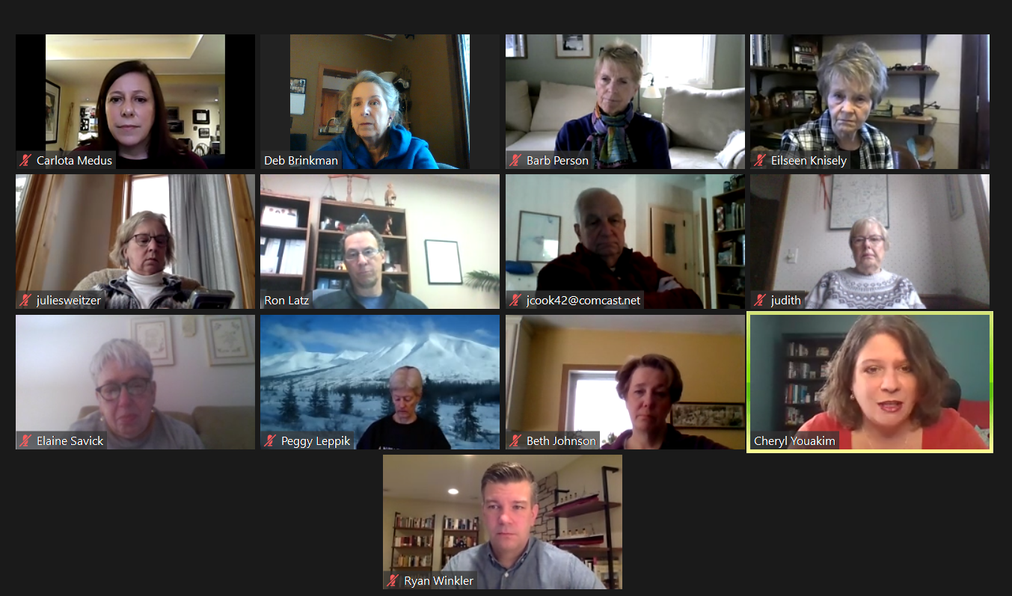

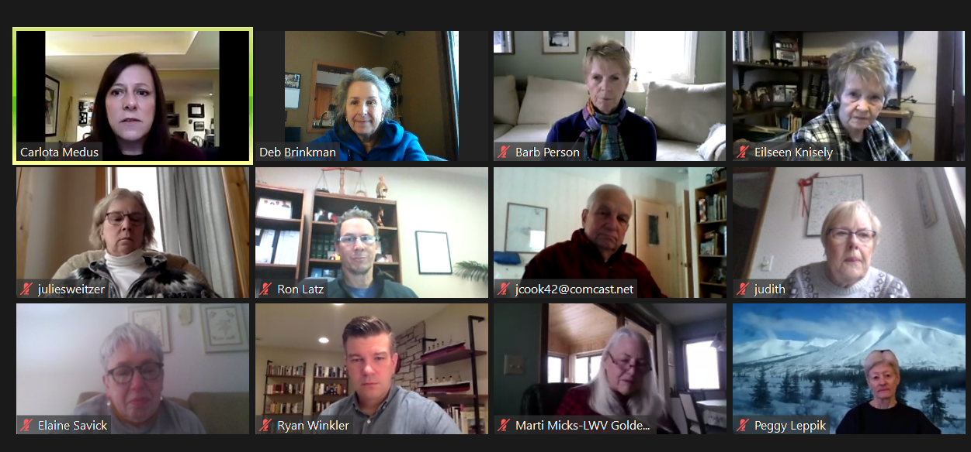
Ryan

proposed/prepared QUESTIONS
- What are your top priorities for the legislative session? Please be specific as possible as to why those are your priorities and what legislation you plan to support. [If returning] Is there anything different about your priorities this session compared last session?

- Redistricting only happens every 10 years. This means that for most legislators, redistricting would be an entirely new/ process for them- what are your concerns, thoughts, comments?? What should we expect?

- As you are well aware, restoring voting rights to people who were convicted of felonies but are no longer incarcerated- what should we expect? Is this something that will even get any time or consideration this session?
- The legislature has been passing laws in fewer, larger omnibus bills every year since the
1970s. Some believe that these large omnibus bills violate the single subject clause of the Minnesota constitution. Additionally, negotiations between the legislative leadership often stalls, leading to last-minute deals behind closed doors. What is your opinion on these practices? How might they be improved to ensure greater transparency and public participation?

- The pandemic has put a spotlight on the incredibly high number of people experiencing homelessness, but this problem has been building for years. When we ask you about people experiencing homelessness, we often get the same answer: affordable housing. But the issues surrounding homelessness go well beyond being able to rent a two-bedroom apartment for $1000 a month. County and local governments have primary responsibility for dealing with this issue. Do you think the State government should have a more central role in finding and implementing solutions? If yes, what ideas do you have? If no, why not?
- I’ve seen/heard some of you commend our front-line health care workers and EMS for their work on the pandemic- and rightfully so. However, you rarely mention public health. The global pandemic has highlighted a lack of public health funding. The state has been far from willing to fund much of the work on infectious diseases at the state level- much of the funding comes from competitive grants. What solutions and support do you support or propose to increase public health funding and public health education?
- Tell us about your thoughts on clean energy initiatives? What initiatives do you support in confronting climate change?
- A budget shortfall was projected, then it wasn’t…an article was circulated that talked about the budget not being negatively impacted because most of the people who lost their job during the pandemic are low-income workers, so not much of an impact on income taxes or other taxes paid to the state. But sadly that means that those who are the most financially vulnerable are the ones most impacted by this pandemic (for example, not the restaurant owners, but the workers)- what do you plan to do about those impacted?
- This is a budget year- so comment on that.
- Should the state play a role in police reform? If yes, what changes should be implemented at the state-level?
- The pandemic has highlighted big gaps in health care coverage, access, and equity. At the same time, health care providers are suffering tremendous financial losses leading to closures and layoffs. What approaches should be tried at the state level to improve health care for individuals, and help keep providers open?
- Our communities have military grade weapons for sale at our local shopping malls. Can you please go on record and state what your stance is on guns designed for combat warfare available for purchase by civilians? Will you support broader gun control legislation?
- What is your vision for publicly funded elections?

